GOAL
Empowering parents, teachers and students with strategies to change inappropriate behaviors. Effectively carry out these strategies by teaching children to stay in control of self and be consistent.

Focus
In order to have true change in a child’s behavior you must have involvement from the parent, teacher and child. The objective of ETSM is to develop children, who have no self-control and give them autonomy to make good decisions. Children will understand that self-control is vital for their personal growth.

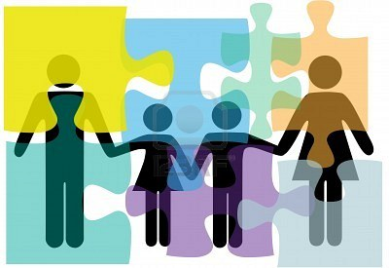

METHODOLOGY
In order to have true success in a child’s behavior, teacher and parent must be active participants in the overall success. This can be accomplished in three ways:
- Taking Control of the Classroom.
- Preventing Behavior Problems in Children.
- Running a School with Less Stress.
Who is eligible to attend ETSM?

- Students that have difficulty following direction.
- Students that are defiant and or oppositional.
- Students that have trouble focusing on an assigned task.
- Students that are unable to resolve conflict.
- Students who are unable to control their anger.
- Students who display lack of self-control.

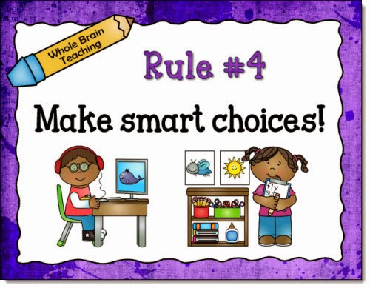

objectives
- Give choices that are age appropriate instead of threats and demands.
- Give consequences with empathy for inappropriate behavior.
- Be consistent in delivering consequences and caring them out.
- The ability to set limits.
- Stay in control of self and the situation.
- Give children autonomy for growth.
- Develop children who are accountable and responsible for their actions.

Taking control of the Environment
Every time you tell a child you can control something you can’t, your credibility goes down. When you have no control, go for relationship building and techniques that make them wish they complied.
- Giving consequences with empathy.
- Give little choices instead of threats and demands.
- The importance of bonding with students.
- The cycle of threats.
- Being consistent, something should always happen for inappropriate behavior.

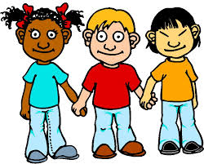

Preventing Behavior Problems

Children don’t learn from what we say, but what we do and the consequences that follow.
- The power of modeling.
- The art of giving choices.
- Replace don’t with what you want them to do.
- Always be glad to see them.
- Allow children to solve their problems.



Education and
Therapeutic
Support at
Madison

ETSM
Pre K – 8th Grade
Bell Times: 8:15am-3:12pm
1118 S. 7th St.
Saint Louis, Mo 63104
Director: Marvin Echols, Jr. (314) 345-5651
Fax: (314) 244-1951

